Overview of the Theory of Probability and Statistics
Probability is the branch of mathematics that studies the possible outcomes of given events together with the outcomes' relative likelihoods and distributions. In common usage, the word “probability” is used to mean the chance that a particular event (or set of events) will occur expressed on a linear scale from 0 (impossibility) to 1 (certainty), also expressed as a percentage between 0 and 100%. The analysis of events governed by probability is called statistics.
A properly normalized function that assigns a probability “density” to each possible outcome within some interval is called a probability function (or probability distribution function), and its cumulative value (integral for a continuous distribution or sum for a discrete distribution) is called a distribution function (or cumulative distribution function).
A variate is defined as the set of all random variables that obey a given probabilistic law. It is common practice to denote a variate with a capital letter, most commonly . The set of all values that can take is then called the range, denoted 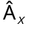. Specific elements in the range of are called quantiles and are denoted . The probability that a variate assumes the element is denoted 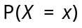.

Distribution Function
The distribution function 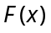, also called the cumulative distribution function (CDF) or probability distribution function, describes the probability that a variate takes on a value less then or equal to a number of .
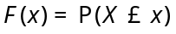
A distribution function satisfies
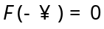, 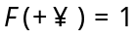
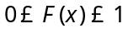
There exist distributions that are neither continuous nor discrete.
Given continuous probability function 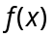 assume that you with to generate numbers distributed as using a random number generator. If the random number generator yields a uniformly distributed value 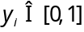 for each trial , the formula connecting with a variable distributed as is then 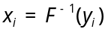, where 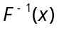 is inverse function of distribution function .

Probability Function
The probability function, also called probability density function (PDF) or density function, of a continuous distribution is defined as the derivative of the (cumulative) distribution function.
For continuous distribution we have
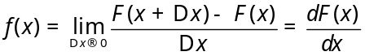
and the distribution function is therefore related to a continuous probability function by
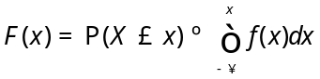
For discrete distribution
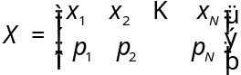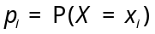
we have
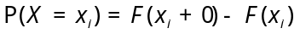
and the distribution function is related to a discrete probability function by
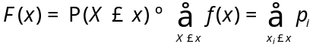
A probability function satisfies
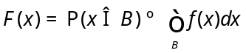 – for continuous distribution
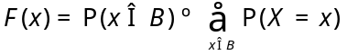 – for discrete distribution
and is constrained by the normalization condition
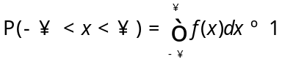 – for continuous distribution
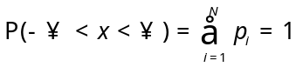 – for discrete distribution
Special case is
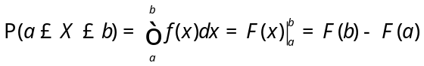
A probability function is always non-negative
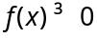
which is equivalent to statement that distribution function is monotonic non-declining function, i.e.
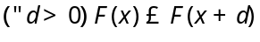

Quantile
The quantile is the inverse of the distribution function. The q^{th} quantile is the value of 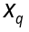 at which distribution function reaches , i.e.
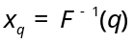

Mode
The mode is the value of 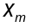 at which probability function reaches maximum, i.e.
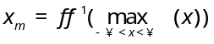.

Expectation Value and Population Mean
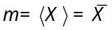
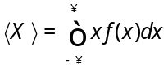
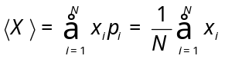
Let 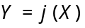, then
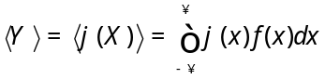

Moment
The n^{th} raw moment 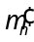, i.e. moment about zero, of a distribution is defined by
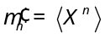, i.e.
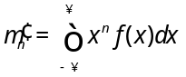 – for continuous distribution
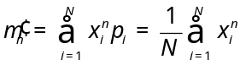 – for discrete distribution
Raw moment is sometimes called also “crude” moment.
The n^{th} central moment 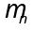, i.e. moment about mean, of a distribution is defined by
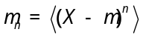, i.e.
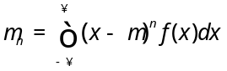 – for continuous distribution
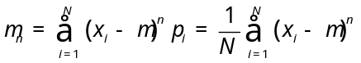 – for discrete distribution

Characteristic Function
The term characteristic function is denoted 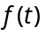 and is defined as the Fourier transform of the probability density function using Fourier transform parameters 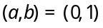,
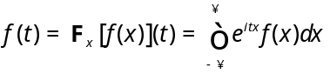
which is equivalent to
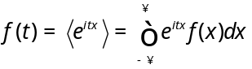
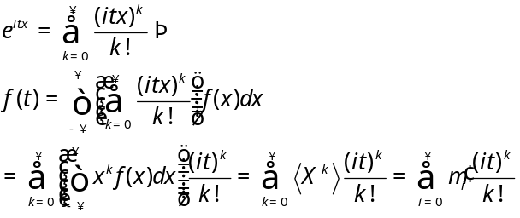
A statistical distribution is not uniquely specified by its moments, but is uniquely specified by its characteristic function,
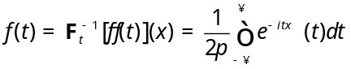
Characteristic function can therefore be used to generate raw moments,
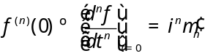

Moment-Generation Function
Given a random variable and a probability distribution function , if there exists an 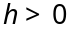such that
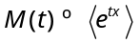
for 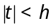, then 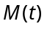 is called the moment-generating function.
For a continuous distribution,
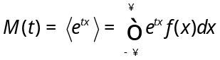
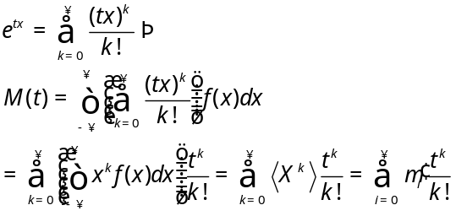
As its name suggests, it can be used to generate raw moments,
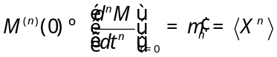
Therefore, the mean and variance can be expressed in terms of raw moments as
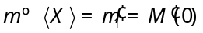

Mean Absolute Value
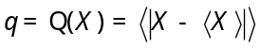
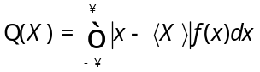
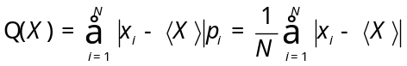

Variance
For a single variate having a distribution with known population mean 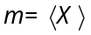, the population variance 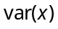, commonly written 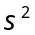, is defined as,
For continuous distribution, it is given by
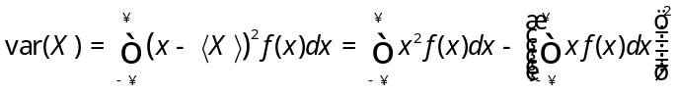
For discrete distribution with possible values of , the population variance is therefore
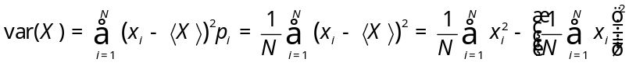

Standard Deviation
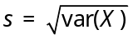

Variation Coefficient
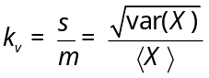

Chebyshev Inequality
If a random variable has a finite mean and finite variance 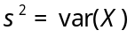, then for each 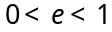,
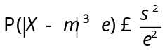
or for each 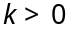
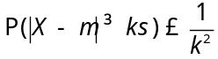

Gamma Distribution
Consider a distribution function of waiting times until the 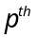 Poisson event given a Poisson distribution with a rate of change ,
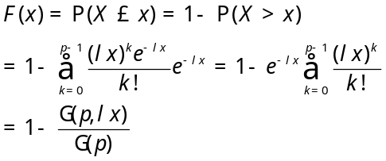
for 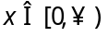, where 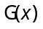 is a complete gamma function, and 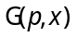 an incomplete gamma function. With an integer, the distribution is a special case known as the Erlang distribution.
The corresponding probability function of waiting times until the Poisson event is then obtained by differentiating
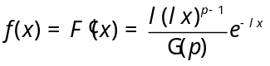
Parameter is called the shape, and 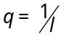 is time between changes.
Special cases:
- Exponential Distribution: 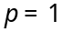
- Erlang’s Distribution: 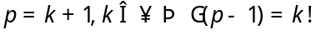
- χ² Distribution: 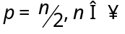
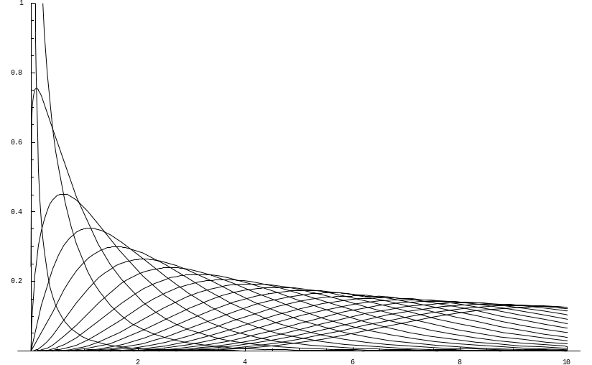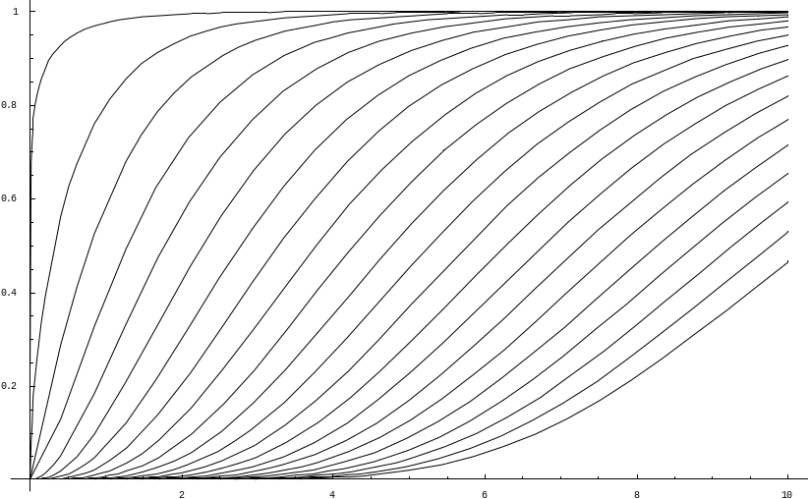
PDF
CDF

Moment-Generation Function
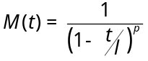

Expectation Value and Variance
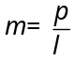, 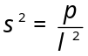

Gamma Function
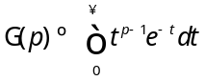
Note: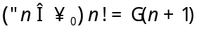
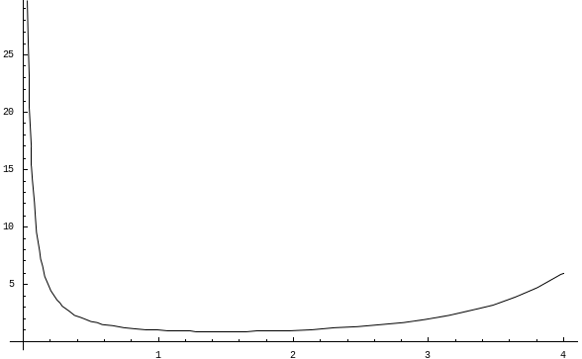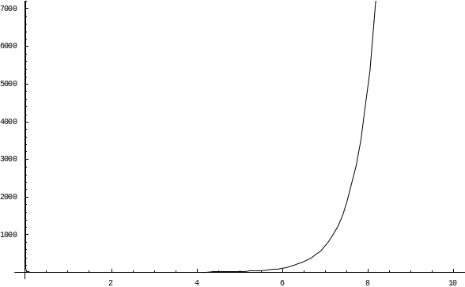

Incomplete Gamma Function
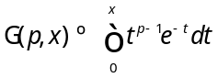
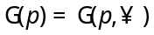
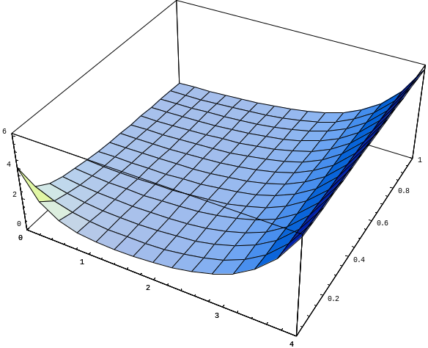

Regularized Incomplete Gamma Function
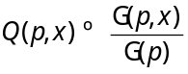

Algorithms

Sample Population Mean and Variance Computation
When computing the sample variances numerically, the mean must be computed before can be determined. This requires storing the set of sample values. However, it is possible to calculate using a recursion relationship involving only the last sample as follows. This means itself need not be recomputed, and only a running set of values needs to be stored at each step.
In the following, we use somewhat less than optimal notation to denote calculated from the first samples, i.e., not the 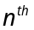 moment,
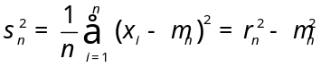,
where
giving finally
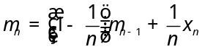
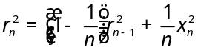
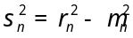
with start conditions
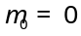, 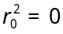

Moving Average
Given the sequence 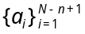 defined from by taking average of subsequent terms,
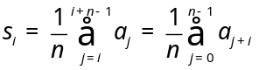
The plot bellow shows 2- (red), 4- (yellow), 6- (green) and 8- (blue) moving averages for a set of 100 data points.
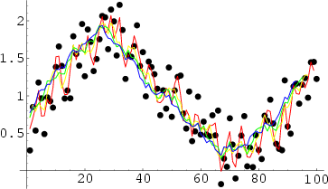

Exponential Average
Averaging algorithm that is mostly used in digital signal processing and is based on the infinite impulse response low pass filter,
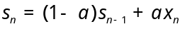
Simply, it represents RC filter where 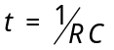 that is used to remove AC component just leaving DC component of the input signal.
Note similarity of the sample mean and variance recursive expressions to exponential average algorithm
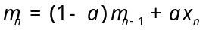
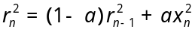
where represents inverse of the constant of the filter, i.e. 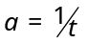.
The exponential average algorithm is similar, on the other hand, to the moving average algorithm, where the size of the moving average slide window is actually constant of the IIR LPF. Note, however, that IIR LPF response is exponential (and slower) and moving average response is linear (and faster).
Here is the comparison of moving average (red) and exponential average (blue) algorithms.
